1. This is 3rd Grant Type.
2. **Scenario**:
   1. When Authorization Server, Resource Server and Client belong to same organization.
   2. **Typical Use Case**: Microservices.
   3. **For Example**:
      1. We have bank app.
      2. Where we have micro services for Loan, Card, Account.  
         **NOTE**: Along with these services, organization also maintains authorization server too to generate access token.
      3. Now, user is presented with Login page from the organization where the user enters credentials.  
         **NOTE**: User believes the organization as the authorization server is also from the same organization.
      4. Then, an access token is generated.  
         **NOTE**: User is not redirected to some other web site as the auth server is also from the same organization.
      5. One service needs data from other service related to same user.
      6. So, one service uses the same access token to get the resource from other service.  
         **NOTE**: User is not redirected to login page each time when accessing the resource from a different micro service as all the micro services belong to the same organization.
3. 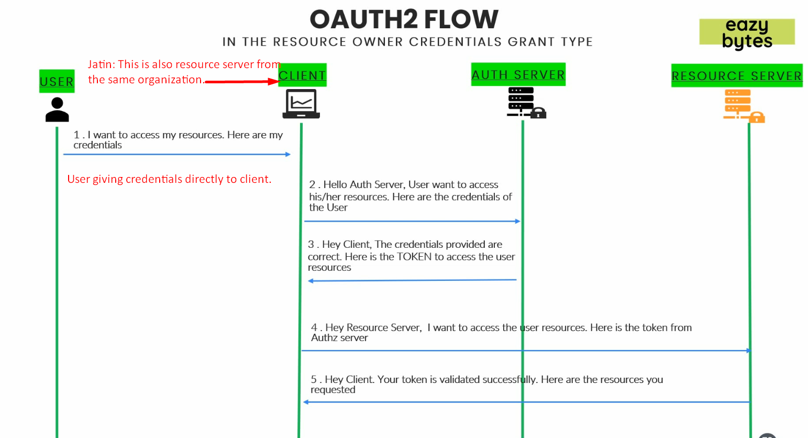
4. 